FOR IMMEDIATE RELEASE
Contact: Robert D. Temple
1421 Hillcrest Road, Cincinnati OH 45224
513-542-2640 (phone); 419-844-5762 (fax); edge-effects@fuse.net

Edge Effects: The Border-Name Places by Robert D. Temple


Award-winning travel narrative
examines how frontiers enrich cultures and boundaries define them,
how edges shape local history and lives.

“The author provides a fascinating and entertaining look at more than eighty
North American border towns in Edge Effects…It’s a title I’ve ordered for my personal library.” ~ Historian Michael Dixon, Elkton MD

Who among us hasn’t felt the thrill of discovery when crossing a border, whether into a new county, a new state, or a new country? To great acclaim, Edge Effects: The Border-Name Places by Robert D. Temple has won the coveted Silver Medal from the Independent Publisher (IPPY) Book Awards in the Travel Essay category for 2010. Readers will appreciate its keen exploration of more than eighty North American border towns and the insightful stories about why people cross the lines to do everything from buying fireworks and lottery tickets to gambling to getting married.

Divided into geographic regions such as “The East,” “Appalachia,” “Tall Grass,” “Basins and Ranges,” and “Deserts,” each section of Edge Effects contains a dozen or so chapters highlighting uniquely named border towns across the U.S. – think Mardela Springs, Virgilina, Texarkana, Idavada, and Calzona to name just a few – and the singular qualities that define them. Comments Temple, “Along with finding these towns in the first place comes adventure in exploring them, by highway, four-wheel-drive, boots, and kayak, as well as encountering memorable locals – historians, farmers, waitresses, cops, forest rangers, railroaders, and ne’er-do-wells.”

This collection of essays, described by reviewers as “quirky,” allows Temple, a historian and adventurer at heart, to investigate concepts of borders, boundaries, frontiers, margins, and marginality, as well as survey lines, battle lines, picket lines, and color lines. Along the way, he discovers how edges shape local history and the lives of those who inhabit them.

Numerous five-star ratings on Amazon.com attest to the book’s appeal. For more information, media commentary, and press resources, see www.edge-effects.com or contact the author.

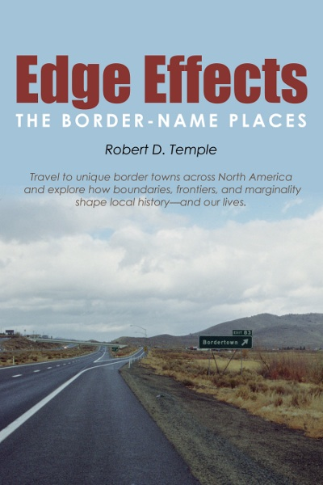
Edge Effects: The Border-Name Places is available at www.edge-effects.com, from on-line retailers, and through local bookstores.
# # #
Edge Effects: The Border-Name Places by Robert D. Temple; Nonfiction; Hard cover $47.95; Soft cover $37.95; E-Book $6.00

Author: Robert D. Temple, Ph.D., brings a strong background in history, languages, and scientific research. He explored the back roads and archives of North American for ten years to write this book. When not traveling, Temple lives with his wife, Sue Auerbach, in Ohio, Virginia, and Yucatán.

